Project 5

Use the following code to generate two lists of random numbers

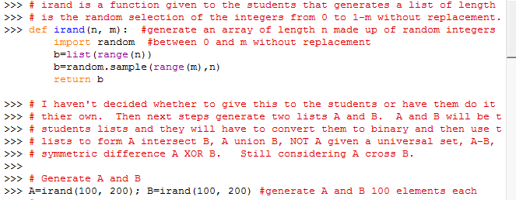

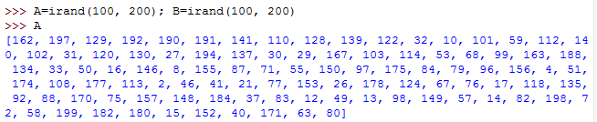

Form and sort in ascending order the intersection and union of the two sets. Print off the intersection followed by list a and b sorted into ascending order. (This is the only way I can check your output any any reasonable time. Then print off the union of the two sets followed by a and b sorted into ascending order. Given that the universal set is the whole numbers between o and 200 inclusive form and print not A in ascending order. Form and print A-B in ascending order. You can use the built in sort algorithm below and the logical operators == etc but no other built in set functions.

